**TASK 01:**

#include <iostream>

using namespace std;

int main() {

int num1,num2,hcf,lcm;

cout << "Enter the first number=";

cin>>num1;

cout<<"Enter the second number=";

cin>>num2;

if (num2!=0){

hcf=num1%num2;

}

lcm=(num1*num2)/hcf;

cout<<"LCM of the given numbers is = "<<lcm<<endl;

return 0;

}

**OUTPUT:**

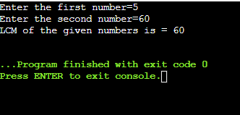

**TASK 02:**

#include <iostream>

using namespace std;

int main() {

int x,y,t,ans;

cout << "Enter the first number of series=";

cin>>x;

cout<<"Enter the last number of series=";

cin>>y;

cout<<"Enter the number of terms=";

cin>>t;

ans=(t/2)*(x+y);

cout<<"The sum of Arithmetic Progression is = "<<ans<<endl;

return 0;

}

**OUTPUT:**

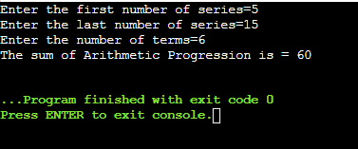

**TASK 03:**

#include<iostream>

using namespace std;

int main() {

int size;

cout << "Enter the size of the diamond: ";

cin >> size;

for(int i = 1; i <= size; i++) {

for(int j = 1; j <= size-i; j++) {

cout<<" ";}

for(int j=1;j<=2*i-1;j++){

cout << "*";

}

cout << "\n";

}

for(int i=size-1;i>=1;i--){

for(int j=1;j<=size-i;j++){

cout<<" ";}

for(int j=1;j<=2*i-1;j++){

cout<<"*";

}

cout << "\n";

}

return 0;

}

**OUTPUT:**

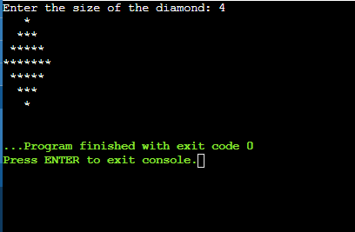

**TASK 04:**

#include <iostream>

using namespace std;

int main(){

int dec,count=0,i;

cout<<"Enter the decimal number : ";

cin>>dec;

int binary[32];

if(dec==0)

{

binary[count++]=0;

}

else{

while(dec>0){

int a=dec%2;

binary [count++]=a;

dec/=2;

}

}

cout<<"The value of given number in binary is : ";

for(i = count-1;i>=0;i--){

cout<<binary[i];

}

cout<<endl;

return 0;

}

**OUTPUT:**

